Add to power input design description

The following circuit principle will be used for reverse polarity protection.
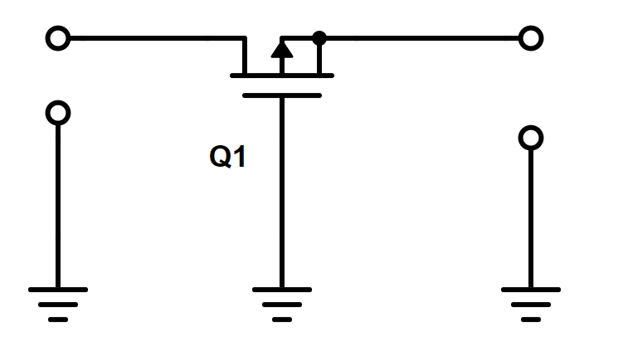
Figure 1: Principle of reverse polarity protection schematic
In correct polarity there will be a voltage drop between Q1 source and gate. Transistor works as ideal diode. In reverse polarity source and gate will be at equal voltage, transistor will be off and no reverse current flows.
Gate-source voltage will be clamped with 8.2V … Zener diode. MM3Z8V2ST1G was chosen due to the fact that it was available in Krakul component library and it has been used previously in similar application.
10kΩ resistors limit the Zener current. In normal operation at 24V the current would be ~ 2mA.
The final schematic is as follows:
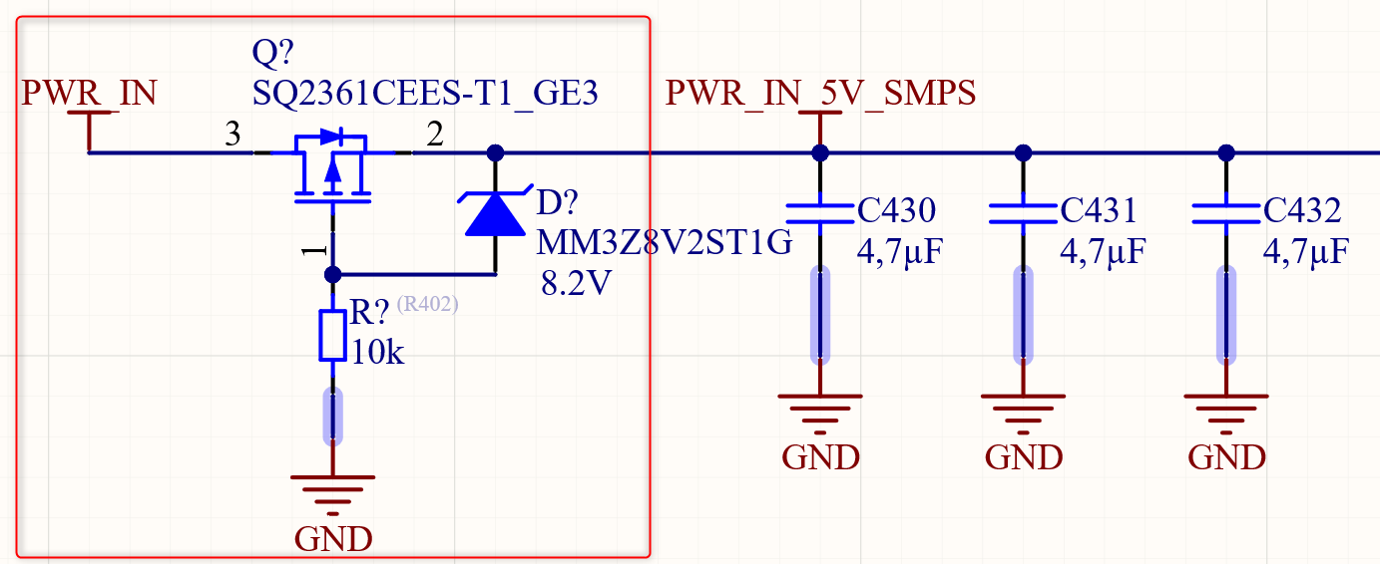
Figure 2: Reverse polarity protection circuit
Schematic was tested in simulation.
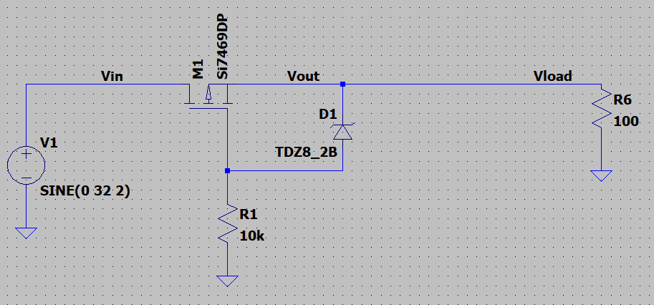
Figure 3: LTSpice simulation schematic
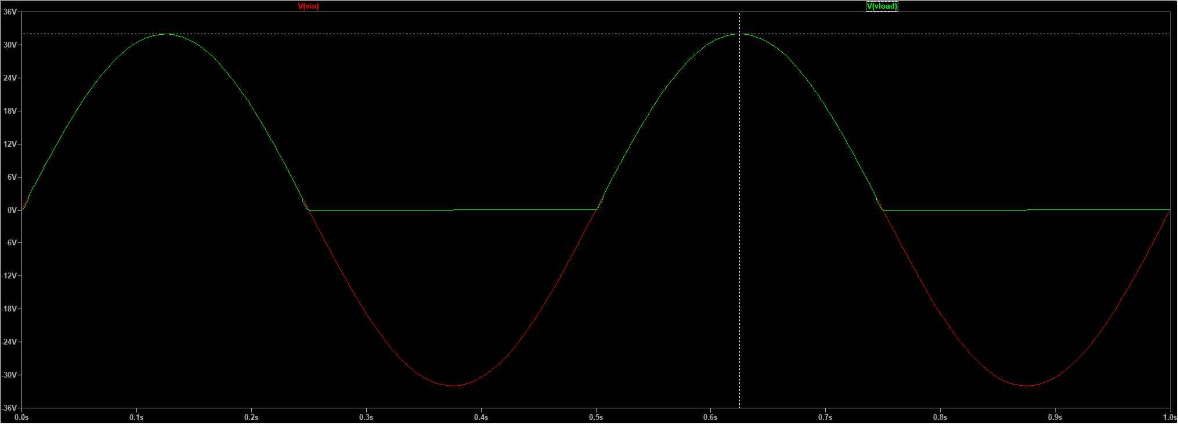
Figure 4: LTSpice simulation results

For P-MOSFET the following parameters are important:
V_{DS} – At least 55V, better to select from 60-65 V range for margin.
I_{D} – At least 2A since the current through 5V regulator is ~1A plus some margin.
V_{gs} – over 10V.
SMD package
SQ2361CEES-T1_GE3 – was chosen. Available in the library, fits in all criterias.
P-MOSFET shall have 2x 0402 0R resistor footprints in parallel. These will not be populated but give an option to bypass the protection.

